Building Bridges
Child Development Center
“Where Great Minds Grow”

Family Handbook
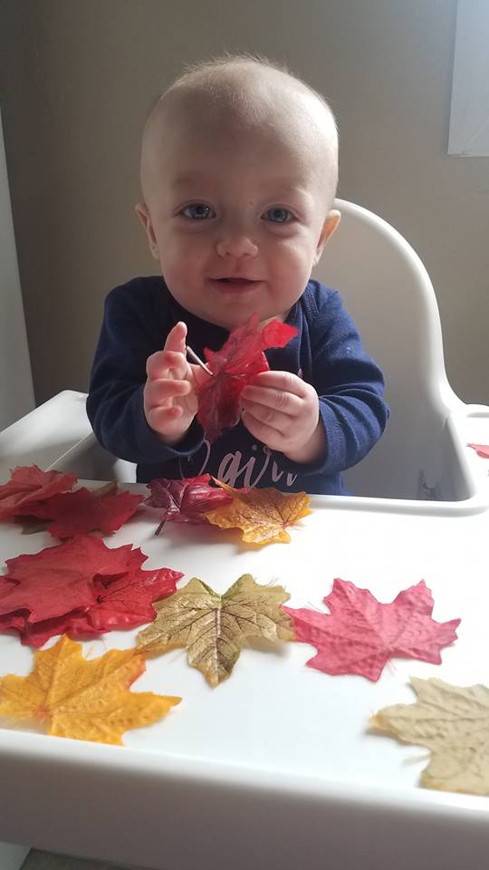
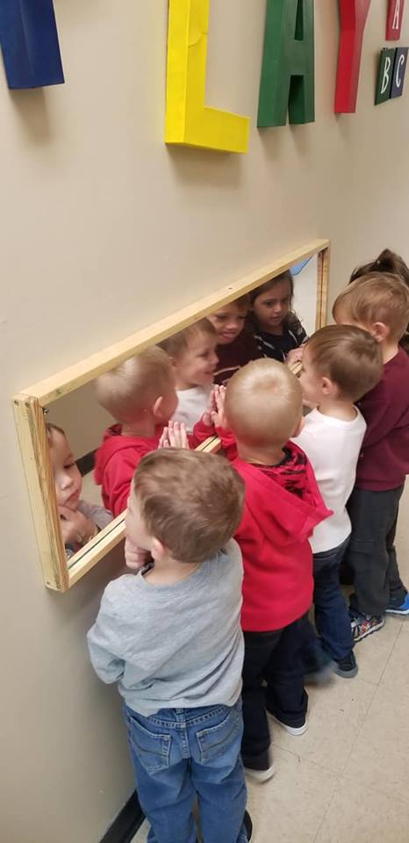

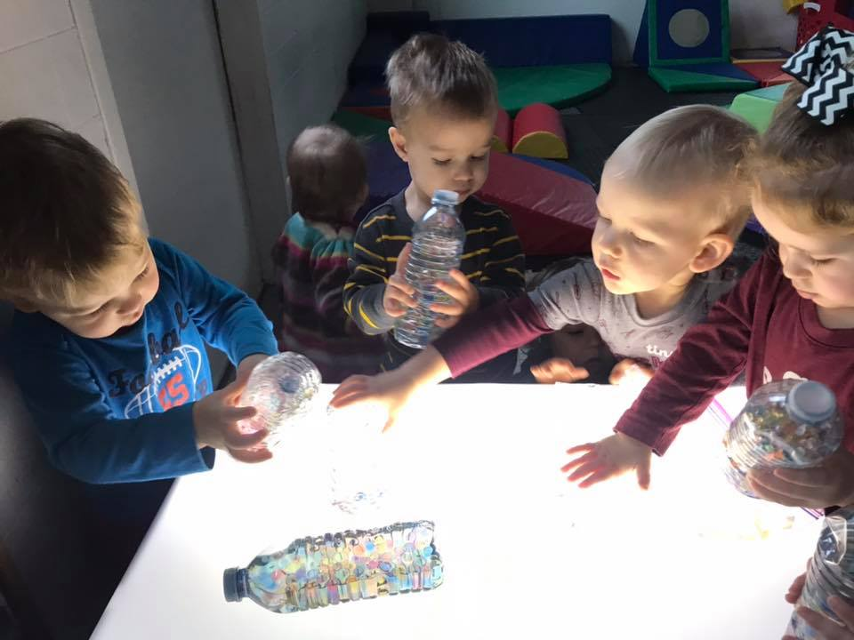

Address: 4194 Pepperell Way Dublin VA 24084
Phone: 540-674-0101 Fax 540-674-4002
Email: buildingbridges.2005@yahoo.com
Website: www.buildingbridgescdc.net
Who We Are
Building Bridges Child Development Center strives to promote the importance of early childhood education. We embrace the diversity of our children, families and our community.
Our work is guided by the results of research studies about the best ways to support children and their families. We provide programs that develop the early skills and nurture the strong parent-child relationships that create the foundation for successful learning.
We would like to extend you a warm welcome. It is our desire to assure you that your child is comfortable and secure while they are in our care.

Mission and Vision
Vision Statement: We envision a world where all children are prepared for success in school through highly effective early childhood education.
Mission Statement: Building Bridges CDC promotes educational equity for young children through family engagement, teacher preparation and effective early education policy.

Philosophy and Purpose
At Building Bridges CDC, we base our delivery of services on how your child sees and experiences his or her environment. Viewing the environment through “the eyes of a child” guides the program to provide services based on what the child needs to develop, such as trust, feelings of security, independence, and initiative.
The goal is to enable each child to develop his or her potential in all aspects of physical, social, emotional, and intellectual development by providing individualized supports to ensure that he or she has access to activities, materials, and other learning opportunities.
Building Bridges CDC values an inclusive setting for all children, regardless of family circumstances, that honors and respects their diverse abilities, cultural beliefs and traditions.
At Building Bridges CDC, we believe that you are both the expert on your child and his or her first and primary teacher. Our purpose is to support your efforts in supporting your child’s development and to help you develop the resources to meet your needs and self-determined goals.

Values
The values that underlie all efforts and activities undertaken by Building Bridges CDC are Excellence, Stewardship, Growth, Innovation, Collaboration, Diversity, Family-Centered, Integrity, and Accountability.

Beliefs
We believe that:
- Integrated, comprehensive services for children best serve the whole child within a family system.

• Early childhood is the best time to support optimal development of children.
• High quality programs support the optimal development of individual children, so they can succeed in school, and in life.
• Growth and change are vital to a healthy organization.
• Reflective practice ensures that the program’s practices, services, guidelines, and procedures align with our values, beliefs, and early childhood theories.

Consistent Staff
All staff and children are assigned to a specific classroom. All classrooms have assigned teachers to provide consistency for the children in the classroom. The children will have familiar faces and teachers they can name daily to help provide bonding and familiarity on a routine basis.

Parents’ Rights and Responsibilities
As a Building Bridges CDC parent, you have the right to:
• Have your culture, beliefs, concerns, and values welcomed, appreciated, respected, and reflected in your child’s program.
• Receive information about all aspects of the program communicated to you in a language you can understand.
• Visit or observe your child in the school environment.
• Ask questions of and give feedback to staff members.
• Confidentiality in matters involving the welfare of every child and family in accordance with program policies and the law.
• Be notified of significant changes in staff within 48 business hours.
• Be notified of policy and procedural changes within 48 business hours.
As a Building Bridges CDC parent, you have the responsibility to:
• Understand this handbook and adhere to its guidelines and procedures.
• Ensure the program has current emergency contact information and that your emergency card is up to date (e.g., current phone numbers of your home, work, and cell phones).
• Keep your child’s immunization and well child exam records current. Disclose essential information about the care of your child with staff.
• Respect, approach, and talk with staff as professionals who work with you to provide a quality early childhood education program.
• Respect the diversity, culture, and language of all children, families and staff.
• Raise issues promptly and directly, seeking mutually agreeable solutions that honor the needs of the organization and your family.
• Participate in goal setting as well as parent-staff conferences and or parent meetings.
• Keep your child safe and in your direct supervision while he or she is in your care at school, especially during drop-off and pick-up. Proximity ensures for your child’s safety and builds school readiness skills as they learn to stay close to their caregiver.

Guidelines and Procedures
Families Served
Building Bridges CDC provides families with children from birth (6 weeks) to age twelve years quality early childhood education.
Hour of Operation
7am- 5pm Monday through Friday
Holiday Closing
Building Bridges CDC will be closed on the following day:
- Martin Luther King Jr. Day (Staff Development Day)
- President’s Day
- Memorial Day
- Good Friday
- Independence Day
- Labor Day
- Veteran’s Day (Staff Development Day)
- Thanksgiving Day & the day after
- Christmas Eve & Christmas Day
- New Year’s Eve & New Year’s Day
If any of these dates fall on a weekend, we reserve the right to choose an alternative date to close. These are paid holidays for our staff. Tuition rates are not adjusted for these closings.
Enrollment
An eligibility application is first completed which places a child on the waiting list if all eligibility documents are verified. Enrollment materials are completed once a child is mapped into an enrollment vacancy.
Documentation is required for licensing and to assist with the CACFP Food program. All eligibility applications must be completed before the enrollment process can be completed.
- Application
- Physical and Immunization
- Verification of birth/ Birth Certificate
- Registration fee ($50.00 1st child, $10.00 per additional child/ children)
An Enrollment Team meets weekly to review openings to ensure for a successful transition for the child, family and staff.

Payment Policy
For your convenience, we accept the following methods of payment for your child care fees:
- Cash
- Personal or Certified Checks
- Credit/ Debit (2% service charge)
- Direct Deposit
- ADC (Aid for Dependent Children)
- VDSS Assistance
Building Bridges CDC is only able to provide Full Time Enrollment. Rates are not reduced due to absences, planned closings or inclement weather dates.

Confidentiality
Information regarding Building Bridges CDC families is kept confidential within the program. Information is shared on a need-to-know basis with professionals who provide child and family services and to ensure the safety of children enrolled in the program. Information is shared with outside providers only with appropriate authorization.
Communication
Effective communication with children and families is central to the program’s core beliefs.
Child Abuse and Neglect
All staff at Building Bridges CDC are mandated reporters and are required by law to report any incident of suspected child abuse or neglect to the Department of Human Services.
The Building Bridges CDC philosophy is to act in the best interest of the child, to be as supportive and as non-threatening as possible to the family, and to maintain the child and family in the program. Parents are responsible for reporting any inappropriate staff behaviors or actions toward children.
Suspected child abuse or neglect by a parent, guardian, staff, or other persons may be made to:

Pulaski County Department of Social Services
53 Commerce St. Pulaski VA 24301 540-980-7995
Child Abuse Hotline: 1-800-552-7096
Information regarding reporting child abuse is provided to parents during the enrollment process and parents are informed of staff’s mandatory reporting requirements of suspected abuse and neglect prior to their child entering the program.
Grievance and Problem-Solving Process
Parents should feel free to discuss any school-related concerns with your child’s teacher as most issues can be resolved at this level. If an issue cannot be resolved at that level among the parties involved, parents are encouraged to take the concern to the Administrative Director: Carol Martin or Owner/ Administrator Tina Martin.
School Closings
School closing announcements are made on the REMIND text system and our Facebook Newscast page.
Transportation
Building Bridges CDC is committed to the safe and responsible transportation of children. Transportation will be provided to and from Pulaski Elementary School and Dublin Elementary School. Students attending Critzer Elementary school will be escorted to the public-school bus stop at the edge of our parking lot at the designated times. The driver will follow vehicle safety guidelines for children and adults. Use of an appropriate car seat is required.
Media Use
Television and video usage for children less than two (2) years of age is not utilized. Children two (2) years of age and older may have limited media use for educational purposes. Children are not exposed to media with explicit language or topics.

Classroom Closing Procedures
Child attendance is tracked and documented throughout the day. At school closing (6 p.m.), every classroom, closet, bathroom, and hallway are checked to guarantee all children are safely out of the buildings.
Volunteers
Building Bridges CDC highly values the participation of parents and community members. Volunteers in the classroom must be at least 13 years of age:
• Parents are encouraged to observe their child’s classroom and should contact their teacher or Administrative Director to setup a time.
• Individuals who volunteer must complete a Volunteer Interest Assessment and submit it to the Administrative Director. The Director will review and schedule a time to meet regarding assignment and orientation. All volunteers will be supervised by Building Bridges CDC Staff.
• All volunteers will receive a Volunteer Handbook and an orientation (including a review of Building Bridges CDC confidentiality, discipline, and child abuse guidelines) before their service begins.
• Volunteers must be supervised and have clearly established duties.
• Volunteers cannot be used to fulfill the required staff-child ratio.
• Where Building Bridges CDC collaborates with a community agency such as the Pulaski County Public Library that agency’s screening process is sufficient to meet program requirements.

Parents in the Program
Your participation in the Schools and programs Building Bridges CDC is highly valued and supports our school community. We ask that you consider making a commitment to volunteering at least eight (8) hours a year. There are a number of ways in which your time and talents can be helpful and useful to the program. Talk with your child’s Teacher or the Administrative team about other volunteer opportunities you would find meaningful.
Parent-Teacher Conferences
Building Bridges CDC provides two planned opportunities a year for you to meet with your child’s teacher. We welcome you to plan additional meetings with your child’s teacher or with Administration at any time you feel it necessary. Please speak with the Administrative Director to setup this meeting.
BBCDC Monthly Newsletter
A family newsletter is published every month. Interesting articles on child development and upcoming parent/family activities are included in this newsletter.
The Building Bridges PTO Committee
The Building Bridges PTO Committee is open to all Building Bridges CDC parents. The Committee meets monthly and has responsibilities to plan, coordinate, and organize ongoing parent activities with the assistance of the Administration. PTO Committee members elect their own officers who conduct committee business and facilitate the meetings where they lead parents in supporting their child’s early childhood education.
Educational Opportunities for Parents and Families
Building Bridges CDC offers workshops and training activities throughout the year in which you can participate. These opportunities can teach new skills and provide information about interesting, useful subjects. Contact your Administration team or your child’s teacher for more information.
Guidance and Discipline
The foundations of self-regulation begin at birth when adults interact with babies in ways that teach them to feel safe, to feel loved and to know that their needs will be met. These early interactions with parents, guardians and caregivers establish the foundation to develop the child’s capacity to wait, give, trust, love, and care for others. Child behavior is a form of communication.
Our goal is to teach children to become conscious of hurtful behavior patterns and find respectful ways to get their needs met. We teach these skills through a positive approach built upon empathetic and loving relationships.
At Building Bridges CDC, we use Conscious Discipline, a social emotional curricular approach. This approach may look different than the discipline you may have seen in school! It is all about connections.
Conscious Discipline
Conscious Discipline is based on developmentally appropriate practices. Conscious Discipline employs seven conscious skills including composure, encouragement, assertiveness, choices, empathy, positive intent, and consequences.
We focus on:
• Teaching children the social-emotional and communication skills necessary to control themselves, problem solve, build self-esteem and develop pro-social skills. Creating a school family that builds connections between families and schools, teachers, teachers and children, and children.
• Constructing routines, rituals and structures that leave coercion, force, fear and external rewards behind, and encourage self-motivation, helpfulness, problem-solving and connections.
Conscious Discipline asks adults to:
• See misbehavior as a call for help instead of disrespect
• See conflict as a teaching opportunity rather than a disruption to learning
• See children as capable of self-regulation instead of needing to be controlled
• See connection as the most powerful motivating force for achievement
• Understand that social connections are the basis for problem-solving
• Understand that what you focus on, you get more of.
Building Bridges CDC does not use the following as a form of discipline:
• Withhold, deny or force food or rest
• Punish children for toileting accidents
• Use corporal or harsh punishments, including: pinching, shaking, spanking, punching, biting, kicking, rough handling, hair pulling, humiliation or fear-based
• Use restraints, meaning the use of physical force or other means to restrict the child’s freedom of movement
Guidance for Families
You are your child’s first and most important teacher. Research has shown that parent involvement goes hand in hand with children’s success in school. When significant and repetitive behaviors that raise safety, concerns arise it will be required that you are part of the process.
These may be:
- Weekly/monthly meetings with Teachers and Staff
- Positive Behavior Support Plans
- Two-way communication forms
We work hard to ensure that we have the clearest understanding of the communication behind the behavior a child may be demonstrating. In an effort to do that, staff will complete a behavior incident report. This is not a punishment, but a way to ensure that we can have open communication with families. This also allows us to collect some valuable information on potential factors that could be influencing behavior.
Situations where behavior tracking, and documentation will happen:
- Aggression to another child or adult that results in physical pain or harm to that person (includes kicking, hitting, biting, scratching)
- Running out of classroom, off playground, or from group without responding to the calls of the adult
- Intentionally injuring self in manner that may cause serious harm (severe head banging, biting self)
Behavior tracking forms will also be completed if a child continues to engage in problem behavior despite efforts to redirect to use alternative skills.
Contacting/Informing the Parent/ Guardian
Parent/Guardian will be notified as soon as possible if harm was caused to another child or adult. In most cases staff will review the form with you at time of pickup; unless immediate assistance needed.
There are times when we will work with families to create a child’s individual positive behavior support plan which is intentionally designed to extend beyond the school day. This type of plan will be completed after behavior tracking data has been collected on significant and repetitive behaviors that raise safety concerns. Such plans are created with parents/guardians and teachers to help families support their child’s development of self-regulation skills.
Examples of behaviors that benefit from this type of plan include:
- Fighting, hitting, biting, or other physical aggression
- Taking or damaging school property
- Using abusive language/gestures
- Leaving classroom or playground without permission
- Throwing objects, tipping over shelving

Arriving at the School
To ensure for safe loading and unloading, designated parking is available for parents. Please follow parking safety expectations. It is imperative that children remain at their parents’ side while entering and exiting the building.
Only adults eighteen years or older and approved by the parents or guardian on this agreement may drop off or pick up a child.
If your child will not be attending school, please contact us by 9am. It is our policy to contact families if we have not heard from them by 9am each day to ensure that the child is where they need to be. Drop off is restricted between 11:30am -2pm due in order to provide a quiet atmosphere for children resting.
Infants, toddlers, and preschoolers thrive on predictable and consistent routines. Please note that inconsistent routines are especially problematic to children who experience separation anxiety. Individualized activities are planned during the daily routine, normally occurring at the beginning of the day when children are rested and alert. Timely arrival in the morning ensures your child can participate in these activities.
Parents should consider the amount of time that children are in group care and if it is appropriate for the child.
When accepting a child who arrives late, teachers will inform parents that they will monitor how the child transitions into the classroom. If there are difficulties with how a child transitions into the classroom, parents and teachers will discuss adjustments to the child’s routine at pick-up time.
A late fee is charged for pick-ups after the 6:00pm scheduled pick up time. ($1.00 per minute per child)
What to Do Upon Arrival
1. Families receiving VDSS tuition assistance will need to check-in and swipe your VDSS card at the POS machine.
2. Sign your child in on the Arrival/Departure Sheet in the classroom.
3. Communicate questions or concerns with the teacher.
Absences Refer to our illness policy in the back of this handbook for special guidelines as to when you should keep your child home from school.
What to Do When Leaving for the Day
1. Sign out on the Arrival/Departure Sheet in the classroom.
2. Collect your child’s clothes and belongings.
3. Check child’s cubby or file for communications from staff.
4. Families receiving VDSS tuition assistance will need to check-out and swipe your VDSS card at the POS machine.
Authorized Pick Up
Children are released only to individuals listed on the pick-up form authorized by parents and/or guardians. Individuals listed, but not known to staff, are required to show valid photo identification (I.D.) Parents must inform staff when one of the listed people on the pick-up form will pick up their child.
Important Note
The school must have legal documentation in your child’s file stating custody guidelines when families have specific legal custodial arrangements (e.g., custody and restraining orders, court orders). Only in an emergency can a parent or guardian verbally authorize a person to pick-up who is not designated on the pick-up form. It is important that legal documents are provided to the Administrative team for the child’s file and are updated if any changes occur.
Late Child Pick Up
Parents and guardians are responsible for promptly picking up their child at the end the 5pm closing time each day. When a child is not picked up, Building Bridges CDC staff are to follow the outlined procedures to assure the safe continuous care of the child. If the child is not picked up, the teacher or Administrative team will attempt to contact the parents/guardians. If unable to contact the parents, the teacher or Administrator will call designated individuals on the emergency contact card.
Late child pickup will be addressed in accordance with the following guidelines:
1. A late fee will be assessed.
2. Designated staff are required to contact the Pulaski County Department of Social Services thirty minutes after the closing if unable to reach anyone from your child’s emergency contact card.
3. Families who are late more than once may be required to meet with designated staff to develop a back-up plan for pick up in case of future emergencies.
4. Habitual late pick-ups may result in additional interruptions in service.
Withdrawal from the school
It is required that the parent notify the Administrative Director two weeks prior to the date of the child’s leaving.

Interruption in Services
When parents/guardians are unable to meet the financial obligations services may be interrupted.
Organization of the Classrooms in the School
Staff-Child Ratios
Classrooms # of Adults to Children Max # of Children
Infant Room 1adult to every 4 children
Toddler Room 1 adult to every 4 children
Preschool 1& 2 Rooms 1 adult to every 8 children
Preschool 3 & Pre-K Rooms 1 adult to every 10 children
School-age Room 1 adult to every 18 children
Building Bridges CDC is committed to recruiting highly qualified staff who reflect the demographics of the children and families we serve. There is ongoing training throughout the year for all teachers to link research with their knowledge of best practice in the early childhood field. A strong training plan ensures our ability to create the best possible learning environment for children and promotes individual competence for early childhood teachers. Teachers and staff are trained in First Aid, CPR, and Universal Precautions. A criminal record check by the Virginia Department of State Police, along with a review from the Central Registry, is obtained for all Building Bridges CDC employees.
Your Child’s Safety
Your child’s health and safety are the primary concern of all Building Bridges CDC staff. The following are procedures for ensuring and protecting the health and safety of your child in the school throughout the course of the day:
• Parents or other individuals picking up a child that require assistance entering the building will be escorted to their destination by program staff.
• Staff greet you at arrival and/or departure, and parents, family members over the age of 18, or guardians sign children in or out on the designated form in the classroom.
• If there is reasonable suspicion that the adult designated to pick up your child is impaired by drug, marijuana or alcohol use, local authorities will be contacted. The next prioritized person on your emergency contact list will be notified to pick up your child.
• Parents are responsible for supervising children at all times while the children are not in the care of Building Bridges CDC staff.

Procedure for Identifying Where Children are Always
Attendance is monitored throughout the day including when children are in the classroom, when they exit the classroom and the school, and when they are outside of the classroom. Teachers always keep attendance records with them. The schools have fenced outdoor play environments and children can be always seen.
Visitors to the School
The school maintains a record of all visitors that includes the date, the visitor’s name and the purpose of the visit.
Parking Lot Safety
The safety of our children, families, faculty and community members is of utmost importance. Children are everywhere and even with reminding, children can quickly dart out in front of cars. Please always keep your children close to you and do not let them run in between parked cars. Be on alert for children coming from any direction.
We’re all busy and have places to go, however, to ensure safety for all, we must always be on alert and be prudent in our actions.
Here are some expectations when driving on our campuses:
1. Drive slowly (5 MPH) when entering the parking lot.
2. Follow the flow of traffic when driving in the parking lot.
3. Do not use your phone to talk or text while driving on campus.
4. Be courteous, cautious and aware of others. Children can appear from anywhere and are often not visible above tire height.
5. If approached by an upset person, do not engage in an argument or altercation. Please report your interaction to our Administrative Director for assistance.
Safe Sleep Policy
Providing infants with a safe place to grow and learn is very important. For this reason, we follow the American Academy of Pediatrics (AAP) recommendations and the Consumer Product Safety Commission as well as all regulatory bodies, to provide a safe sleep environment and reduce the risk of sudden infant death syndrome (SIDS). Infants are placed on their backs for every sleep and will keep soft bedding such as blankets, pillows, bumper pads, and soft toys out of their baby’s sleep area.
FIELD TRIP PARENT/GUARDIAN PERMISSION FORMS
Specific objectives for each field trip are developed. Completed forms that reflect preparation and follow-up discussion and include activities to make each field trip or educational activity will be approved by the Administrator. There will be at a minimum of 24 hours’ notice of a field trip with permission form and an opt out notice available. Parents/guardians should always be notified whenever children leave the schools for a field trip. All field trips should be placed on the monthly calendar. If a field trip is arranged after the monthly calendar has been sent home, a notice will be sent to all parents/guardians and must be posted on the parent/family bulletin board in advance of the trip.
Additionally, a sign should be posted on the door of your child’s classroom indicating the children’s whereabouts and time of return.
We welcome you to participate on the field trip; however, please plan for your own transportation if there is insufficient room on the van.
Unexpected Situations and Emergencies Inclement Weather
Our schools close or are on a delayed start whenever there is a safety concerns from inclement weather.
Watch for a REMIND text alert or a Facebook Newscast announcement.
Emergency Procedures
Building Bridges CDC, is required to have an emergency management plan, include procedures for evacuation, shelter in place, lockdowns and lockout situations. Drills for fire evacuation and shelter in place (tornado) are practiced monthly at the school, and lockdowns and lock ins are practiced quarterly with all children and staff. Emergency management will be instructed through Pulaski County Emergency Service Coordinator.
If there is an actual emergency, children and all adults will go to a designated safe place; assemble; staff will account for each child and adult; and comfort and aid will be provided as needed.
Parents/guardians will be notified of the location by the REMIND text alert system as well as an announcement on our Facebook Newscast. Parents will also be contacted by phone in the event of the center closing or in the event of an evacuation procedure. In the event of an emergency, all center phone lines will be forwarded to Tina Martin’s (Owner) and Carol Martin’s (Admin Director) cell phone numbers to keep communication lines open. If we will need to evacuate the center, we will be transported by a Pulaski County Public Schools bus to Pulaski County High School (64300747). The alternative location would be Pulaski Elementary School (643-0737), depending on the emergency.
Building Bridges staff will take the essential documents and supplies needed for each age group. We will make every effort to ensure safety and protection of each child in our care under an emergency.
Continuity of Operations
Building Bridges will keep on hand back up supplies such as ready to eat food, water, infant formula and baby food and all additional necessary items needed to ensure continuity of operations during emergency responses. A plan will be in place to inventory these needed items to keep on hand.
Staff will remain onsite to ensure ratios are met and regulations are followed.
Parent emergency notification system will be in place to notify parents in case of activating Emergency Response Plan.
Incident and Accident Reports
All Building Bridges CDC employees are responsible for prevention, non-medical first aid, documentation, and notification of any incident, accident and/or injury involving any child under their supervision. School staff is responsible for learning and enforcing safety procedures
The child’s parents/guardians are notified of all incidents and called immediately if medical attention is needed. Emergency contact information is updated yearly unless a need arises to make changes throughout the year. Parents/guardians receive a copy of the Incident/Accident Report Form.
School Day Illness
When you are notified that your child is ill during the school day, you will need to plan to have your child picked up from the school within one hour. At that time, you may receive an illness report. Based on the information indicated on the referral, any medical follow-up indicated will be required prior to your child returning to school (see ILLNESS POLICY: WHEN TO KEEP YOUR CHILD AT HOME).
Lost Children
Building Bridges CDC is committed to providing a safe environment and supervision of all children enrolled in the program.
• All children must be well always supervised by their responsible caregiver.
• Attendance is monitored throughout the day including when children are in the classroom, when they exit the classroom and school, and when they are outside the classroom. Teachers always keep attendance records with them. The schools have fenced outdoor play environments and children can be always seen.
• Any time an authorized adult (e.g., Director, Program leader, other staff etc.) takes a child out of the classroom, the teacher must be notified. An adult must always stay with the child.
• In the unlikely event a child is unaccounted for while in our care, we will conduct an immediate search and contact the parent and the authorities as needed.

The Food Program
General Information
Food service for Building Bridges CDC is served in a pleasant and relaxed mealtime atmosphere with developmentally appropriate furniture and eating utensils. To encourage independence and socialization, food is served family style where children and the teachers sit at the same table and share the same meal. We will serve Breakfast, Lunch and an afternoon snack daily.
An adult should be seated with the children during the meal times because role modeling is essential to the development of their healthful eating habits and positive attitudes toward nutrition.
Children should be offered all foods and encouraged (in a friendly, non-directive manner) to take a serving and try the food. Children will never be forced to take a food they do not want, and children are never required to eat more of a food than they want.
Cycle menus are designed to offer the children a variety of foods which consider USDA Food Regulations, cultural, religious, and ethnic preferences, and broaden the child’s food experience. Variations to the cycle menu are available only with a doctor’s special diet statement. The program serves a breakfast, lunch, and afternoon snack following USDA nutritional and portion guidelines appropriate for the child’s age.
Breastfeeding and Bottle Feeding
If you wish to breastfeed your child, you are welcome to stay within the classroom. Commercially prepared formula is mixed according to instructions and will be placed in a bottle marked with the child’s name. All premixed bottles of formula or breast milk are appropriately refrigerated. Program approved formulas are provided for families. Children between the ages of 1 year and 2 years of age are given whole milk once they no longer take formula or breast milk. Children over 2 years of age are given Fat free or 1% milk. Other types of milk can only be given at this age under a physician’s orders with parental/guardian permission.
Special Situations
If your child has an allergy to foods, or is on a special diet, Building Bridges CDC will follow the information provided by their doctor’s written special diet form. Special diets are served only upon instruction of the child’s physician and upon the request of the parent/guardian.
Food from Home
Building Bridges CDC follows procedures from the USDA food safety guidelines. These guidelines do not permit food from home to be brought to the schools and served during class time. Parent/family activities may include cultural sharing of food and potlucks.

Daily Routines Rest or Quiet Time
Building Bridges CDC provides a quiet rest or naptime for children during the day. Each classroom’s daily schedule is posted on the parent/family bulletin board. Each child has his or her own crib, mat, or cot. Many children will fall asleep during this time.
Teachers encourage resting using calming and quieting techniques (e.g., soft music, dimming lights, and back rubs). Each child has his or her own special routine for relaxing. A labeled favorite blanket sent from home may help children to rest and relax.
Infants sleep according to their own schedule to promote self-regulation.
Diapering / Sunscreen
The Building Bridges CDC staff is trained in proper diapering techniques that are posted at the changing areas in each infant/toddler classroom. Universal Precautions are used. These precautions, which guard against disease, require a change of disposable gloves, washing of child and caregiver hands, and sanitation of the area before and after the changing of each child.
We require diaper cream and sunscreen to be labeled with the child’s name, and we must have an authorization form filled out before we can apply it to the child. Each diaper cream authorization is valid for 10 days, if your child still required cream after that period, you will need to fill outa new form. Please fill out form completely and check the expiration date on your diaper cream / sunscreen.
Toilet Training or Potty Learning
Staff will work with the child and family to provide guidance in toilet training or potty learning. When children develop an awareness of when they are dry and when they are wet or soiled and show an interest in using the toilet, those children may sit on the toilet when other children do. Hands will always be washed at these times. When children experience success in using the toilet and understand the connection between body functions and the toilet, they will gradually use the toilet on their own. If a child understands and is capable but is not willing, then the child is not completely ready to learn how to use the toilet and staff will work with the family to determine when the child is ready.
Class Advancement
There are several factors we consider before advancing a child to the next class:
- Age
- Development readiness
- Toilet Training
- Available space in the next classroom
Parents are given prior notice to the child’s advancement. We begin the process visiting the classroom, and progress to full days. Each child is unique and different and has his/her own adjustment period.
All staff and children are assigned to specific classrooms. All classrooms are assigned teachers to help with staff consistency. Children will have familiar faces and teachers they can name daily to help provide bonding and familiarity on a routine basis.
Clothing and Belongings from Home
Clothing Keep it simple. Dress for fun!
Building Bridges CDC days are filled with all kinds of hands-on learning. Children should wear simple, washable clothing and comfortable shoes. Since our classroom extends to the outdoors, dress your child appropriately for the weather. Days at the schools are sometimes messy, so bring a change of clothes for your child, including pants, shirts, socks, and underwear. Make sure clothing is labeled, including jackets and coats.
When the weather is sunny, and children play outside for an extended period, sunscreen is applied to those children who have signed parent/family permission forms.
Children’s Belongings
Diaper Bags and Backpacks
The children have individual cubbies where they store their personal belongings.
Toys, any food or candy, money, medications, lotions, creams and other items labeled “Keep Out of Reach of Children” are not permitted.
Please make sure ALL clothing and personal possessions are labeled with your child’s name. Children will need to bring a blanket for rest time. All items brought to school should fit in their cubby, this helps to meet Health Department regulations about children’s belongings and proper placement of these items.
We suggest you bring at least one change of clothing (two for Infants and Toddlers.
Labeled bottles of formula or breast milk can be given to the teacher at drop-off. There are special storage areas for all these items.
Laundry Policy
The school staff will be responsible for laundering sheets for the cribs, or cots routinely. Families are responsible for washing wet and or soiled clothing. They will be put in a marked plastic bag for you until you arrive.
Promoting and Protecting Your Child’s Health
If your child has a pre-existing medical condition (for example: allergies, reaction to bee stings, or physical handicap) that required emergency medication, we must have a doctor’s note on file to administer the medication (for example: EpiPen or inhaler) in case of a reaction. We do not give emergency medication without prior written consent from a parent or guardian.
If your child needs medication during the day outside of these emergency situations you will need to plan to give the medication around their day at the center. You may come to the facility to administer medication personally, if you find it necessary for your child. Please keep in mind that fever reducers are not allowed to be given at any time the child is in Building Bridges care.
Medications may not be store in diaper bags or other belongings that children could possibly have access to during the day. This could result in medication being ingested by another child, spilled or lost.
Illness Policy:
When to Keep Your Child at Home
There are three main reasons to keep sick children at home:
1. The child does not feel well enough to participate comfortably in usual activities, (such as; extreme signs of tiredness, unexplained irritability or persistent crying).
2. The child requires more care than program staff can provide, without affecting the health and safety of the other children.
3. The illness is on the list of symptoms or illness for which exclusion is recommended. And remember, the best way to prevent the spread of infection is by practicing good hand washing.
Children with the following symptoms or illness should be excluded from school:
- A fever 101 degrees or more
- Vomiting
- Diarrhea (2 or more loose bowel movements in an hour)
- Other contagious illnesses (unexplained rash, drainage from the eyes, etc.)

DIARRHEA frequent, loose or watery stools compared to child’s normal pattern; not caused by diet or medication | Yes - if child looks or acts ill; if child has diarrhea with fever and behavior change; if child has diarrhea with vomiting; if child has diarrhea that is not contained in the diaper or the toilet, within a 24-hour period
FEVER with behavior changes or illness Note: An unexplained temperature of 100°F or above is significant in infants 4 months of age or younger and requires immediate medical attention. | Yes - when fever is accompanied by behavior changes or other symptoms of illness, such as rash, sore throat, vomiting, diarrhea, behavior changes, stiff neck, difficulty breathing, etc.
“FLU-LIKE” SYMPTOMS Fever over 100°F with a cough or sore throat. Other flu symptoms can include fatigue, body aches, vomiting and diarrhea | Yes - for at least 24 hours after there is no longer a fever, without the use of fever-reducing medicine
COUGHING Note: Children with asthma may be cared for in school with a written health care plan and authorization for medication/treatment | Yes - if severe, uncontrolled coughing or wheezing, rapid or difficulty breathing, and medical attention is necessary
Mild RESPIRATORY OR COLD SYMPTOMS stuffy nose with clear drainage, sneezing, mild cough | No - may attend if able to participate in school activities EXCLUDE if symptoms are severe. This includes fever accompanied by behavior changes and/or difficulty breathing.
RASH WITH FEVER Note: Body rash without fever or behavior changes usually does not require exclusion from school, seek medical advice | Yes - seek medical advice. Any rash that spreads quickly, has open, weeping wounds and/or is not healing should be evaluated
VOMITING two or more episodes of vomiting in the past 24 hrs. | Yes - until vomiting resolves or a health care provider decides it is not contagious. If the child has a recent head injury observe for other signs of illness and for dehydration
CHICKEN POX | Yes - until blisters have dried and crusted (usually 6 days) If blister occurs after vaccination, refer to Health Dept Guidelines
CONJUNCTIVITIS (PINK EYE) OR pink color of eye and thick yellow/green discharge | Yes (bacterial or viral) – children do need to be excluded while symptomatic. Consult a health professional for diagnosis and possible treatment.
CROUP (SEE COUGHING) Note: May not need to be excluded unless child is not well enough to participate in usual activities | Seek medical advice
FIFTH’S DISEASE | No - child is no longer contagious once rash appears
HAND FOOT AND MOUTH DISEASE (Coxsackie virus) | YES – must be excluded if the child has sores that are not dried up. Consult a health professional for diagnosis and possible treatment.
HEAD LICE OR SCABIES | Yes - from end of the school day until after first treatment.
HEPATITIS A | Yes - until 1 week after onset of illness or jaundice and when able to participate in usual activities
HERPES | Not necessary unless the student has open sores and is drooling uncontrollably. Yes - if area is oozing and cannot be covered, such as mouth sores
IMPETIGO | Yes - for 24 hours after antibiotic treatment starts
RINGWORM | Yes - from end of school until after first treatment starts. Keep area covered for the first 48 hrs. of treatment
ROSEOLA | Yes - seek medical advice Exclusion not necessary unless the child has a fever along with the rash
RSV (Respiratory Syncytial Virus) | Exclusion is recommended when a child in not well enough to participate in usual activates and/or is experiencing acute respiratory symptoms stay home. Seek medical advice. Once a child in the group has been infected, spread of illness is rapid.
STREP THROAT | Yes - for 24 hours after antibiotic treatment and the child can participate in usual activities
VACCINE PREVENTABLE DISEASES Measles, Mumps, Rubella (German Measles), Pertussis (Whooping Cough) | Yes - until determined not contagious by health care provider
YEAST INFECTIONS including thrush or Candida diaper rash | No - may attend if able to participate in school activities Follow good hand washing and hygiene practices

Termination of our Relationship
Our goal is to provide the best quality childcare available. We realize however that there may be times children will need to be withdrawn from our program. If at any time you find it necessary to terminate your relationship with us, we require a two week notice written notice prior to the date of withdrawal. If you choose not to leave your child in care during the two-week period, you can pay your two-week notice tuition upon your last day at the center.

I have read and understand the policies outlined in the Parent Handbook

______________________________________ __________________________________________
Parent Signature/ Date Parent Signature/ Date

______________________________________
Administrative Signature/ Date

Photograph Release
At times there may be photographs taken of the activities we have planned. The photographs may be used to promote the center and /or to share with our community. Our BBCDC Newscast page on Facebook is private (parents and staff) and typically the place we share these photographs. We ask that you do not share photographs of other children to your personal Facebook page.
Please sign the statement that applied below.

___ I agree that my child’s photographs can be shared on the BBCDC Newscast which is private for parents and staff.
___________________________________________
Parents Signature/ Date

___ I agree that my child’s photographs can be share on the BBCDC Newscast and for advertising and community promotion.

___________________________________________
Parents Signature/ Date

___ I would prefer that my child’s photograph NOT be shared on any open forum.

___________________________________________
Parents Signature/ Date

